Solving simple Markov model
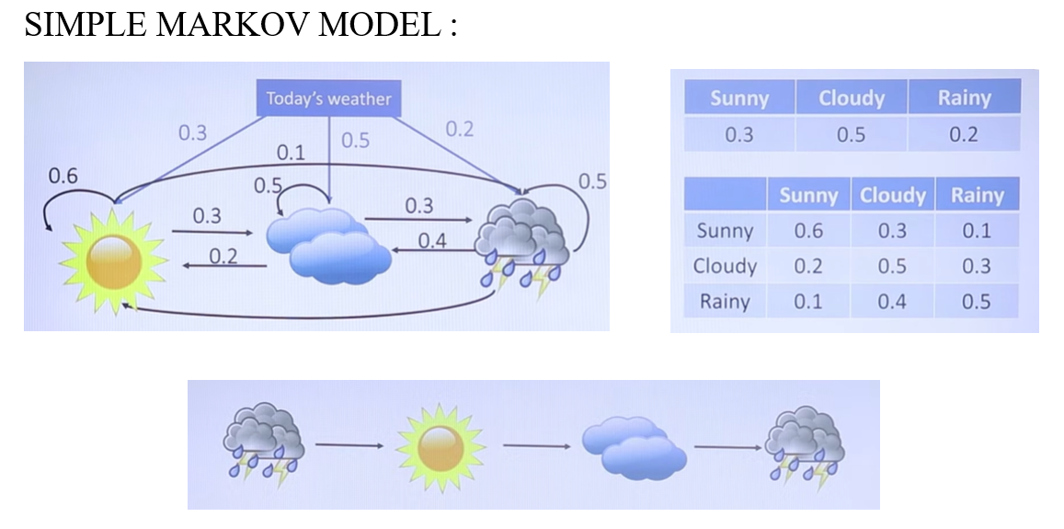
Given states – Rainy -> Sunny -> Cloudy -> Rainy
Markov model probabilities depends on present states.
Step 1- Start with Initial Probabilities.
Rainy initial probability – 0.2. P(Rainy)
Step 2 – Multiply the probabilities based on present states.
Present state – Rainy -> Sunny . Check table P(Sunny|Rainy) = 0.1
Present state – Sunny -> Cloudy . Check the table P(Cloudy|Sunny) = 0.3
Present state – Cloudy -> Rainy. Check the table P(Rainy|Cloudy) = 0.3
Step 3 – Evaluate the final answer – 0.2 x 0.1 x 0.3 x 0.3 = 0.0018

Solving Hidden Markov Model with an Example –
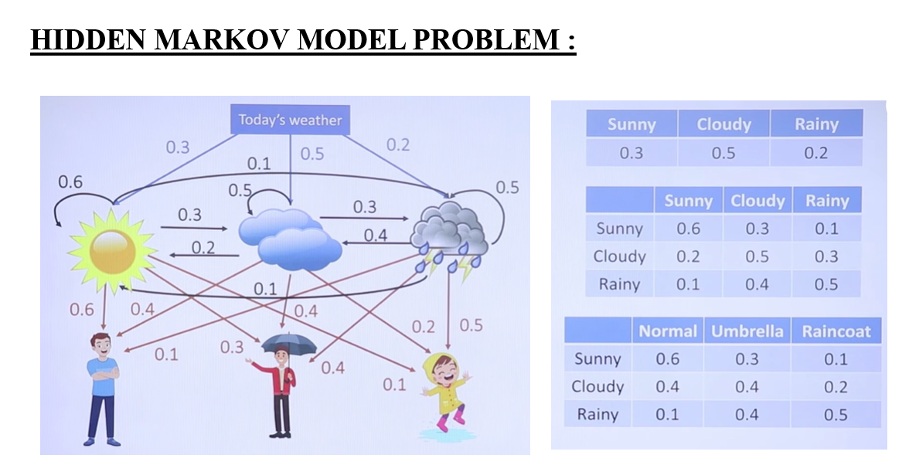
Given problem –

Step 1- Start with emission probabilities.
P(Raincoat|Rainy) – 0.5
P(Noramal|Sunny) – 0.6
P(Umbrella|Cloudy) – 0.4
P(Raincoat|Rainy) - 0.5
Step 2- Use transmission probabilities for the hidden states.
P(Rainy) – 0.2
P(Sunny|Rainy) – 0.1
P(Cloudy|Sunny) – 0.3
P(Rainy|Cloudy) – 0.3
Step 3- Evaluate using all the probabilities.
0.5 x 0.6 x 0.4 x 0.5 x 0.2 x 0.1 x 0.3 x 0.3 = 0.000108

